**Mechi Multiple Campus**

**Tribhuvan University**

 **Institute of Science and Technology**

**A Project Proposal On**

**“Emotion Based Music Recommendation System”**

In Partial Fulfilment of Requirements for the Bachelor Degree in Computer Science and Information Technology

**Submitted to:**

Department of Computer Science and Information Technology

Mechi Multiple Campus

Jhapa, Nepal

**Submitted by:**

Saugat Gautam (24569/076)

Saugat Chapagain (24568/076)

Saugat Adhikari (24567/076)

**Date:**

5th November 2023

**Abstract**

A cutting-edge project proposal called the Emotion Based Music Recommendation System aims to transform how we find and enjoy music by integrating emotional intelligence into the recommendation system. This project attempts to exploit the emotional dimension of music—a global language that may provoke a wide range of emotions to deliver consumers personalized and emotionally relevant music suggestions. The system makes use of advanced artificial intelligence and machine learning techniques to assess and comprehend user emotional preferences as well as the emotional content of music. These two components work together to enable the system to provide personalized music recommendations based on each person's present emotional state, making for a more fulfilling and interesting listening experience. This research examines the unexplored area of emotionally-driven music discovery in addition to meeting the rising need for personalized music suggestions. Collaborative Filtering, Content based Filtering, Convolution Neural Network will be used to create the system. It's important to remember that the precise algorithms and methods implemented may change depending on the size of the project, the data that is accessible, and the amount of complexity that is required. In order to provide a comprehensive and efficient solution that takes into account users' emotional preferences, implementing an emotion-based music recommendation system frequently entails combining several algorithms and techniques.

**Keywords:** Collaborative Filtering, Content based Filtering, Convolution Neural Network

**Table of Contents**

**Introduction** 4

**Problem Statement** 5

**Objective** 5

**Methodology** 6

Requirement Identification 6

Study of Existing Systems / Literature Review 6

Requirement Analysis 7

Functional Requirements 7

Non-functional Requirements 8

Feasibility Study 8

Technical Feasibility 8

Operational Feasibility 9

Economic Feasibility 9

Schedule 9

High level design of System 10

System flow chart: 10

Working mechanism 11

Methodology of the proposed system: 12

**Expected output 13**

**References 13**

# **Introduction**

Music is a complex and universal form of human expression that has the capacity to awaken a wide variety of emotions. It has the capacity to raise our emotional experiences and establish a connection with our deepest emotions. The wealth of music that is accessible through streaming services and digital libraries in the current digital era is both a benefit and a problem. Users are frequently overloaded with options due to an ever-expanding music catalogue, which makes it more challenging to locate music that expresses their present emotional state. In order to overcome this difficulty, the Emotion-Based Music Recommendation System presented in this project will combine machine learning, artificial intelligence, and music analysis to produce an innovative tool for music discovery. Personalized and emotionally impactful music suggestions are provided by this system, which is built to comprehend the emotional content of both music tracks and the emotional preferences of users.

This project has the potential to have a huge influence on artificial intelligence, machine learning, and user experience design as well as the field of music recommendation. In order to fully understand the emotions expressed in songs, we will use content-based filtering to examine the emotional content of lyrics and music recordings. We'll employ collaborative filtering to find people who have our emotional tastes so we can suggest music that makes sense to them. We will also use neural networks, which are a kind of deep learning algorithms, to improve the recommendation system even further. We will use neural networks, which are excellent for recognizing complex patterns, to enhance the emotional analysis and raise the accuracy of the recommendations.

Our Emotion-Based Music Recommendation System will provide a comprehensive solution by merging these algorithms, which not only consider the intrinsically emotional elements of music but also adjust to the emotional moods and preferences of individual users. This combination of collaborative, content-based, and neural network-based methods will open the door to a more engaging, emotionally meaningful, and personalized music discovery experience.

# **Problem Statement**

The enormous variety of music available to consumers in today's digital music world overwhelms them, making it harder and harder to identify music that speaks to their present emotional condition. Current music recommendation algorithms frequently don't take into account the emotional content of music, which leads to suggestions that could not be in line with consumers' emotions and moods. Furthermore, the highly individualized and dynamic character of musical preferences is not taken into consideration by the one-size-fits-all methodology used by many music recommendation systems. Users' feelings are frequently ignored, despite the fact that they have a big say in the music they choose. The problem is the requirement for a music recommendation system that takes into account the affective component of music and adjusts to the fluctuating emotions of its consumers. The goal of the solution is to improve the experience of discovering new music by providing emotionally meaningful suggestions.

# **Objective**

The Emotion-Based Music Recommendation System project's main goal is to create a modern, user-focused music discovery platform that uses sophisticated algorithms and artificial intelligence to deliver individualized music suggestions based on users' emotional states. The project aims to achieve the following goals:

* Provide methods and algorithms to precisely assess and categorize the emotional content of musical compositions, taking into account both the lyrical feeling and the auditory characteristics.
* Use collaborative filtering, content-based filtering, and neural networks to provide users with personalized, emotionally-resonant music suggestions based on their tastes and emotional states.
* Provide an interface that is simple to use that is straightforward and user-friendly so that users may input their current emotional states and quickly access recommended music.
* Develop a system that can easily assess the musical qualities of the track that is being played and suggest other tracks that relate to the same genre, pace, or mood to make listening to music seamless and enjoyable.

# **Methodology**

This section explains how the project will be done. It lays out the steps and methods that will be used to achieve the goals of the project, including how data will be collected and analyzed, what tools will be used, what algorithms to be used, and how the project will be managed.

## Requirement Identification

Requirements specify what the project must have in order to maximize its usefulness and advantages.

### Study of Existing Systems / Literature Review

The literature research and study of existing system are essential first stages in understanding the current state of technology and the problems in the quickly changing fields of digital music consumption and recommendation systems. The evolution of music recommendation algorithms is revealed via a survey of the literature and an analysis of current systems. Traditional systems, such as those found in Apple Music and Spotify, focus on content-based strategies and collaborative filtering, but they frequently lack emotional relevance and context awareness. Music continuation systems and other context-aware music recommendation systems are becoming more and more popular. To provide recommendations that are more interesting, these systems take into account contextual data including the user's activities, and emotional state. Music continuation systems rely on real-time audio analysis and mood identification to provide emotionally integrated follow-up recordings. Cross-platform integration is becoming more and more popular; it guarantees that consumers get suggestions that are consistent across various platforms.

During the research of our project, we took a look into many websites and found a few written papers on similar topic. We found many projects similar to ours in some way, that we could pick concepts up on and implement in our project on the internet such as:

* <https://www.frontiersin.org/articles/10.3389/fpsyg.2021.759485/full>
* <https://www.mdpi.com/2078-2489/13/6/268>
* <https://www.nature.com/articles/s41598-021-99998-z>
* Mehendale, Ninad “Facial emotion recognition using convolutional neural networks (FERC)”

### Requirement Analysis

An essential stage of system development is requirement analysis, which establishes the functions and performance standards of a system. It comprises understanding user desires, putting recommendation algorithms into practice, guaranteeing real-time analysis, and following with ethical and privacy concerns in the context of an emotion-based music recommendation system. As a result of these standards, a music discovery platform that connects with users' emotions and tastes while preserving performance, security, and user happiness is finally delivered. The system requirements can be classified as functional requirements or non-functional requirements.

### Functional Requirements

Some of the functional requirements are listed below:

* **Real-Time Audio Analysis:** To analyze the music that is currently playing and extract relevant audio properties like tempo, key, and mood, enable real-time audio analysis.
* **Recommendation using Content-based Filtering:** Apply algorithms to examine the emotional content and audio characteristics of musical compositions and create a music recommendation system that makes recommendations based on the user's tastes and music library content.
* **Adding features using Neural Networks:** Use deep learning methods, such neural networks, to improve the accuracy of the recommendation system and use neural networks in music analysis to recognize patterns and extract features.
* **User Emotion Input:** This allows user to search music by providing their current emotional states through an in-built user interface.
* **Music Data Collection:** A full database of music tracks with related metadata, such as musical qualities and emotional content, need to be gathered by the system.

### Non-functional Requirements

Some of the non-functional requirements are listed below:

* **Performance:** To ensure a smooth listening experience, make sure the system reacts to user requests fast and offers recommendations with the least amount of lag.
* **Maintainability:** Create a system that is simple to maintain and update, making it easier to add new features and modifications.
* **Portability:** Users should be able to access the system from a range of devices by having it accessible on many platforms and situations. As long as the project satisfies its minimal configuration, it may be carried out in a variety of operating environments.
* **Accessibility:** The term accessibility describes the degree to which a product, setting, service, or gadget is available to the greatest number of people. For the purpose of enabling an inclusive experience for users with limitations, the system must comply with accessibility requirements.

## Feasibility Study

An Emotion-Based Music Recommendation System feasibility study determines whether the idea is feasible. It examines if the instruments and technology required to identify musical emotions and recommend songs are accessible and affordable. It also tests the possibility of managing a large emotional music database. This study aids in determining if developing the system is worthwhile. It ensures that the system meets user needs and can be implemented without significant issues or expenses. So, we make sure the idea is both solid and feasible before developing the system. Some of feasibility study are:

### Technical Feasibility

In the context of an Emotion-Based Music Recommendation System, technical feasibility evaluates how realistic and easily accessible the resources and technology required for its creation are. It involves evaluating the tools and techniques that are available for sentiment analysis, recommendation engine deployment, and real-time audio analysis.

* **Components Required:**
* Camera or video input device for real-time video capture.
* Computer system with sufficient computational resources.
* **Programming Language:**

**Frontend:** Html, CSS, JavaScript, Bootstrap

**Backend:** Python

**Framework:** Flask, OpenCV, TensorFlow

**Libraries:** NumPy, pandas

* **Integrated Development Environment (IDE):** Visual Studio Code.

### Operational Feasibility

An emotion-based music recommendation system's operational viability analyses how well it can be implemented into current processes. It evaluates how well the workflow, procedures, and resources of the system match. Operational viability also takes into account the system's simplicity of use and support requirements for effective daily operation. We can guarantee that the system can be smoothly integrated into their surroundings by carrying out this study. It provides a workable solution that improves music selection based on users' emotions and is simple to operate and support in actual operations.

### Economic Feasibility

An Emotion-Based Music Recommendation System's economic feasibility assesses the project's economic sustainability. It involves determining the development, maintenance, and operational expenses in relation to the expected gains. It examines revenue modes such as advertising revenue, subscription fee and music providers. It offers a financially sensible way to improve music suggestions based on users' feelings and assists project in determining if the method is economically justified. The project is financially feasible and a wise investment if the benefits surpass the expenses and fit within the allocated budget.

### Schedule

The project schedule is represented in the Gantt chart below:

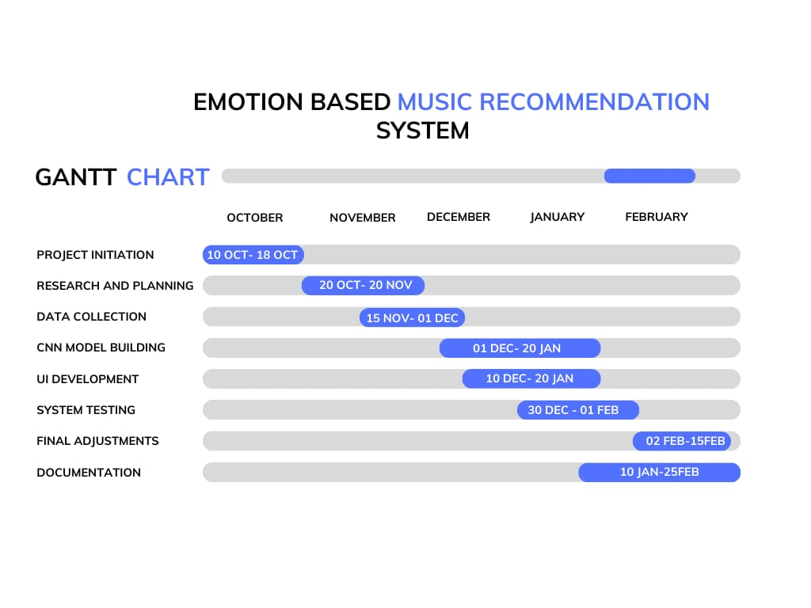

### High level design of System

High level design of the Emotion-Based Music Recommendation System outlines the physical components, working mechanisms and overall system structure of the system. The high-level design of our system is shown below:

### System flow chart:

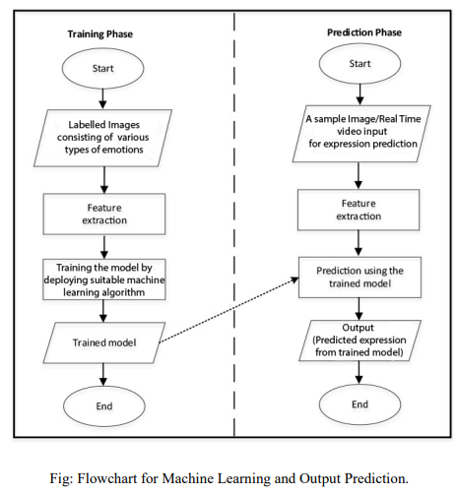

Figure 1: Flowchart for Machine learning and output prediction

### Working mechanism

The technical strategy and procedures we will use to create the Emotion-Based Music Recommendation System are described in this section. The project will follow the following steps:

* + Collect a labeled dataset of facial images or videos.
  + Preprocess the data by detecting and aligning faces, normalizing the images, and extracting relevant features.
  + Develop a machine learning model, such as a Convolutional Neural Network (CNN), to classify facial expressions
  + Integrate the model with a camera device for dynamic emotion detection.
  + Redirect to personalized playlists for each emotion on a music streaming website, based on recognized facial expression
  + Use collaborative filtering and content-based filtering based on the user’s choice of music to recommend music.
  + By seeing trends and parallels in user behavior and emotional reactions, collaborative filtering can enhance recommendations.
  + By assigning emotional labels to tracks and presenting music that corresponds with the user's identified emotional state, content-based filtering can improve suggestion quality.

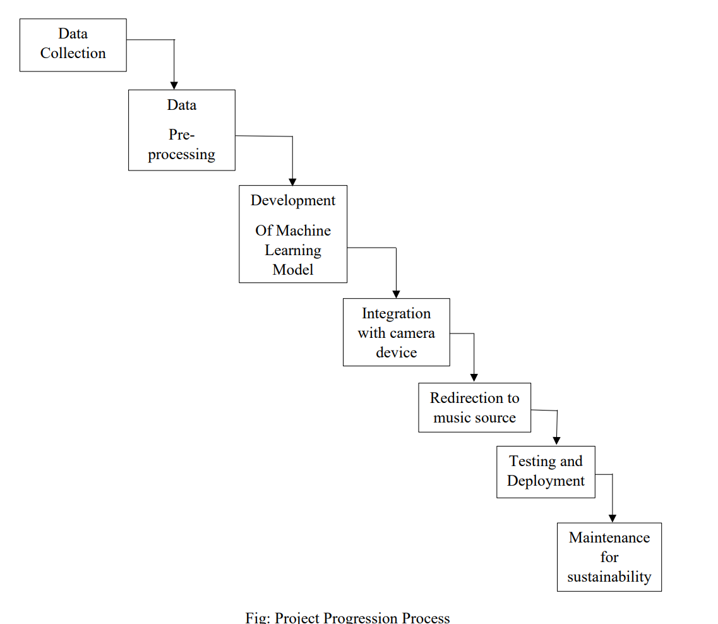

Figure 2: Project progression process

### Methodology of the proposed system:

The methodology of the proposed system describes the technical approaches that we plan to implement throughout the development of the system.

* Data collection:

We collected the music information from a range of sources, such as public music APIs, open-source music datasets, and streaming services. The resources which offers audio features, lyrics, and music metadata are used.

Finding a variety of face image datasets is necessary for data collecting for training a face recognition model, and Kaggle is a useful tool for this process. Since these datasets are usually labeled, the model can be trained to properly identify faces. For the purpose of developing and evaluating models, the dataset is subsequently split into training, validation, and testing sets.

* User Emotion Detection:

We preprocessed the data by detecting and aligning faces, normalizing the images, and extracting relevant features. Then we develop a machine learning model, such as a Convolutional Neural Network (CNN), to classify facial expressions

Which is integrated with a camera device for dynamic emotion detection.

* Music Recommendation algorithm:

The emotion detection function predicts the user’s facial emotion using the CNN model. Based on the user emotion user is recommended personalized playlists for each emotion on a music streaming website and songs similar to the predicted one is recommended there.

# Expected output

The expected output we hope to gather from this project after its completion are :

* Real-time detection and recognition of facial expressions, including emotions like happiness, sadness, anger, surprise, etc.
* Classification of detected facial expressions into specific emotion categories using machine learning algorithms.
* Redirection to respective playlist on a music streaming website based on recognized facial expression and corresponding emotion.
* User interface feedback displaying real-time emotion detection results and music playlist redirection.
* Performance evaluation using metrics such as accuracy, precision, recall, and F1-score to assess the system's effectiveness in detecting and classifying facial expressions.

# References

1. <https://scholarworks.sjsu.edu/etd_projects/632/>
2. <https://towardsdatascience.com/build-your-first-mood-based-music-recommendation-system-in-python-26a427308d96>
3. <https://ieeexplore.ieee.org/document/9596276>

**Dataset from:**

1. <https://www.kaggle.com/datasets/aadityasinghal/facial-expression-dataset>